info@yorkshireyoungmusicians.uk www.yorkshireyoungmusicians.uk
Phone: 07876 154674

YYM Tutor Application Pack

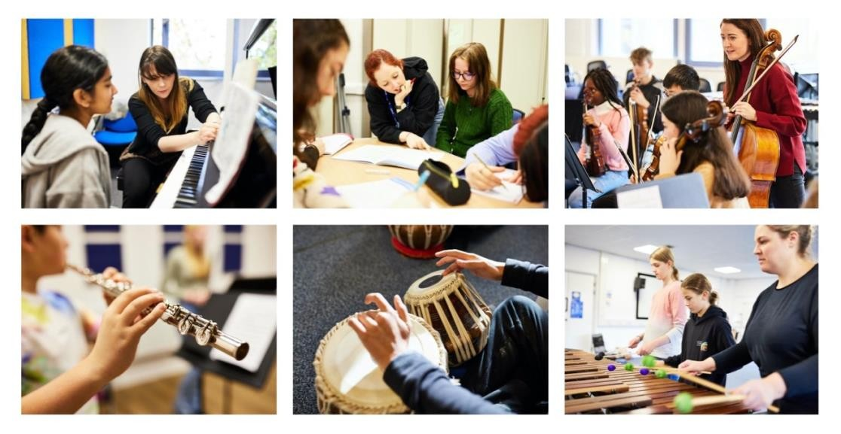

Overview

Thank you for your interest in Yorkshire Young Musicians.
We are looking for tutors to deliver high quality tuition on Sundays. Posts available are:

LEEDS – trombone tutor (2 hours per week)

There is room to expand hours, dependent on student recruitment. Additional theory and/or musicianship teaching may be available for candidates with suitable experience.

Apply by 9am Monday 27th July.

YYM is committed to building a diverse workforce and we welcome applications from candidates with diverse experiences and backgrounds.

About YYM

YYM is a Centre for Advanced Training in Music supported by the Department for
Education’s Music & Dance Scheme. YYM provides access to the highest quality music tuition to promising young musicians aged 8 - 19.

YYM aims to identify and nurture exceptional talent in all areas of performance and across a wide range of genres and traditions. Carefully managed auditions – looking for potential and not just existing achievements - help identify those who will benefit from YYM’s training.

The YYM offer provides one to one instrumental / vocal tuition, ensembles and a broad range of classes on Sundays in Leeds and Hull. YYM tutors are specially selected for their experience in the care and development of young musicians. They are professional musicians, well placed to equip students with all that they need to take their musical studies to the highest possible level.

YYM is proud of the commitment of its staff and the achievement of its students, many of whom progress to study music at conservatoire or university, and all of whom we nurture to lead musically fulfilling lives.

More information about YYM can be found at www.yorkshireyoungmusicians.uk

Key Information

Commitment | 30 Sundays per year,
Location | Leeds Conservatoire
Rate of pay | £37.85 per hour (pay review pending), contribution towards travel
Start date | 6th September 2026

Job Description: Tutor

To teach individual instrumental lessons within Yorkshire Young Musicians, an inclusive Centre for Advanced Training. Additional duties may be required which may include ensemble coaching and preparation for performance.

Main Responsibilities

- Prepare and teach high quality individual instrumental lessons

- Foster and develop the potential and musical talent of pupils participating in YYM and take them to as high a standard of performance as possible

- Continuously monitor and feedback on student progress with particular attention being given to the Individual Learning Plan

- Communicate effectively with students, parents/carers and colleagues, including written reports

- Contribute to the all-round development of the individual and develop the student's self-awareness, self-discipline, self-confidence and self-esteem

- Support and implement YYM policies and procedures including Safeguarding/Child Protection and Health and Safety

- Any other duties commensurate with the level of the post for effective operations and services

Person Specification – what we are looking for

- Experience of teaching to a high level

- Ability to inspire and nurture young musicians to reach their potential

- Degree in music or equivalent professional experience

- High level of expertise in playing and teaching your instrument

- High professional standards, including excellent communication skills

- Demonstrate understanding of safeguarding and child protection, ability to work within YYM policies and procedures

How to Apply

Deadline to apply: 9am Monday 27th July
Interviews: w/c 27 July

To apply, please complete an application form and equality monitoring form and return by email to info@yorkshireyoungmusicians.uk.

Forms can be downloaded from the YYM website. Alternatively, email us to request a copy.

If you would like an initial, informal phone conversation to find out more, please email to arrange a call.

All appointments will be subject to enhanced disclosure from the Disclosure and Barring Service.

YYM is committed to building a diverse workforce and welcomes applications from all individuals.

YYM is committed to safeguarding and promoting the welfare of children and young people and requires all staff to comply with YYM’s Safeguarding policy and procedures at all times. Staff at YYM are expected to promote equality of opportunity for all students and staff, and to support an environment that values diversity.

